Bus Management System

  - Session 2024 - 2028
  - Submitted By:
  - Muhammad Ayan Sajid 2024 CS 661
  - Muhammad Sultan 2024 CS 667
  - Noor ul Ain Fatima 2024 CS 677
  - Submitted To:
  - Mr. Muzamil Dilawar
  - Department of Computer Science, UET Lahore, New Campus

Table of Contents
1 Software Development Life Cycle 4
1.1 Iterative Model 4
1.2 Phase 1: Planning and Requirement Analysis 4
1.3 Phase 2: System Design 4
1.4 Phase 3: Implementation (Iterative Development) 5
1.4.1 Iteration 1: Core Foundation 5
1.4.2 Iteration 2: Admin Administration 6
1.4.3 Iteration 3: Business Logic & Scheduling 6
1.4.4 Iteration 4: Public Interface (Weeks 10-11) 6
1.5 Phase 4: Testing & Integration 6
1.6 Phase 5: Deployment 7
1.7 Phase 6: Maintenance (Ongoing) 7
2 UML Diagrams 8
2.1 Class Diagram 8
2.2 Object Diagram 8
2.3 Use Case Diagram 9
2.4 Package Diagram 10
2.5 Sequence Diagram 11
2.6 Collaboration Diagram 12
2.7 Deployment Diagram 13
2.8 Component Diagram 14
2.9 Activity Diagram 14
2.10 State Chart Diagram 15

Table of Figures
Figure 1 Class Diagram 8
Figure 2 Object Diagram 8
Figure 3 Use Case Diagram 9
Figure 4 Package Diagram 10
Figure 5 Sequence Diagram 11
Figure 6 Collaboration Diagram 12
Figure 7 Deployment Diagram 13
Figure 8 Component Diagram 14
Figure 9 Activity Diagram 14
Figure 10 State Chart Diagram 15

Software Development Life Cycle

Iterative Model
For the Bus Management System, we adopted the Iterative Model. This approach was chosen to allow for the systematic development of the application in distinct, manageable functional blocks (Sprints). This allowed us to verify core functionalities (like data persistence) before building complex user interfaces on top of them.
Justification:
- Risk Mitigation: Critical backend modules (File I/O) were tested early.
- Incremental Delivery: The project was delivered in functional stages (Admin -> Driver -> Passenger).
- Flexibility: Changes in business rules (e.g., scheduling conflicts) could be accommodated between sprints.

Phase 1: Planning and Requirement Analysis
Goal: Define the scope and feasibility of the system.
Key Requirements Identified:
- Authentication: Secure login for Admins and Drivers.
- Role-Based Access:
  - Admin: Full control over buses, routes, drivers, and schedules.
  - Driver: View personal schedule, profile management, day-off requests.
  - Passenger: Public access to search routes and view travel times.
- Data Persistence: All system states must be saved to CSV files to survive restarts.
- Constraints: No overlapping schedules for buses or drivers.

Phase 2: System Design
Goal: Architect the solution to meet requirements.
Architecture:
- Language: C++
- Design Pattern: Object-Oriented Design
  - Models: Bus, Driver, Route, Schedule classes.
  - Controllers (Managers): BusManager, DriverManager, etc., handling business logic.
  - Views: Console-based menus for clean user interaction.
- Data Storage: Custom CSV parsers for buses.csv, drivers.csv, routes.csv, schedules.csv, and users.csv.
Diagrams Created:
- Class Diagram: Defines the static structure of the system, including classes (Bus, Driver, Route), attributes, and relationships.
- Use Case Diagram: Illustrates interactions between actors (Admin, Driver, Passenger) and the system.
- Object Diagram: Represents a snapshot of the detailed state of the system at a specific point in time.
- Package Diagram: Shows the organization of the system into packages (e.g., src, include, data).
- Sequence Diagrams: Details of the dynamic process flow for key operations like Login and Scheduling.
- Collaboration Diagrams: Visualizes the structural relationship and message flow between objects.
- Deployment Diagram: Maps the software architecture to the physical hardware environment (Client PC, File System).
- Component Diagram: Depicts the high-level structural components and their dependencies.
- Activity Diagrams: Models the workflow and logic flow of complex processes like "Add bus" or "Book Ticket".
- State Chart Diagrams: detailed view of state transitions for entities like a Bus (Active -> Maintenance).

Phase 3: Implementation (Iterative Development)
The development was broken down into 6 logical Sprints/Iterations.

Iteration 1: Core Foundation
- Focus: File I/O and Basic Data Structures.
- Deliverables:
  - Implementation of core entities (Bus, Driver, Route).
  - CSV Reader/Writer utilities.
  - Error handling for missing or corrupt files.

Iteration 2: Admin Administration
- Focus: CRUD Operations & Security.
- Deliverables:
  - Login system with encryption/hashing (conceptual).
  - Admin Menu creation.
  - Add/Edit/Delete headers for all entities.
  - Validation logic (e.g., ensuring Bus IDs are unique).

Iteration 3: Business Logic & Scheduling
- Focus: Complex Logic & Rules.
- Deliverables:
  - ScheduleManager implementation.
  - Conflict Detection Algorithm: Preventing double-booking of drivers or buses.
  - Driver Interface implementation.

Iteration 4: Public Interface
- Focus: Passenger Experience.
- Deliverables:
  - Global search functionality (Search by Start/End points).
  - Route calculation and display.
  - Read-only access for guest users.

Phase 4: Testing & Integration
Goal: Ensure system reliability and correctness.
Testing Strategy:
- Unit Testing: Each Manager class was tested individually.
- Integration Testing: Verified that deleting a Bus also cancels associated Schedules.
- System Testing: Automated using a custom SystemTester class.
Results:
- Pass Rate: 100%
- Key Validations:
  - Schedule overlaps detected correctly.
  - Invalid inputs (negative capacity, empty names) rejected.
  - Data persisted correctly after application restart.

Phase 5: Deployment
Goal: Deliver the executable to the user.
Environment:
- OS: Windows
- Build System: PowerShell (build.ps1) and Make.
- Distribution:
  - include/: Header files
  - src/: Source code
  - data/: Default CSV configuration files
  - bin/: Compiled Executable (BusManagementSystem.exe)

Phase 6: Maintenance
Goal: Address future needs and bugs.
- Completed: Sprints 1-4 (Core Dev).
- Current Status: Sprint 5 (Validation & Polish).
- Future Plans:
  - Performance optimization for large datasets.
  - Potential migration to a GUI framework (Qt/wxWidgets).
  - Extended reporting features for Admin.

UML Diagrams

Class Diagram
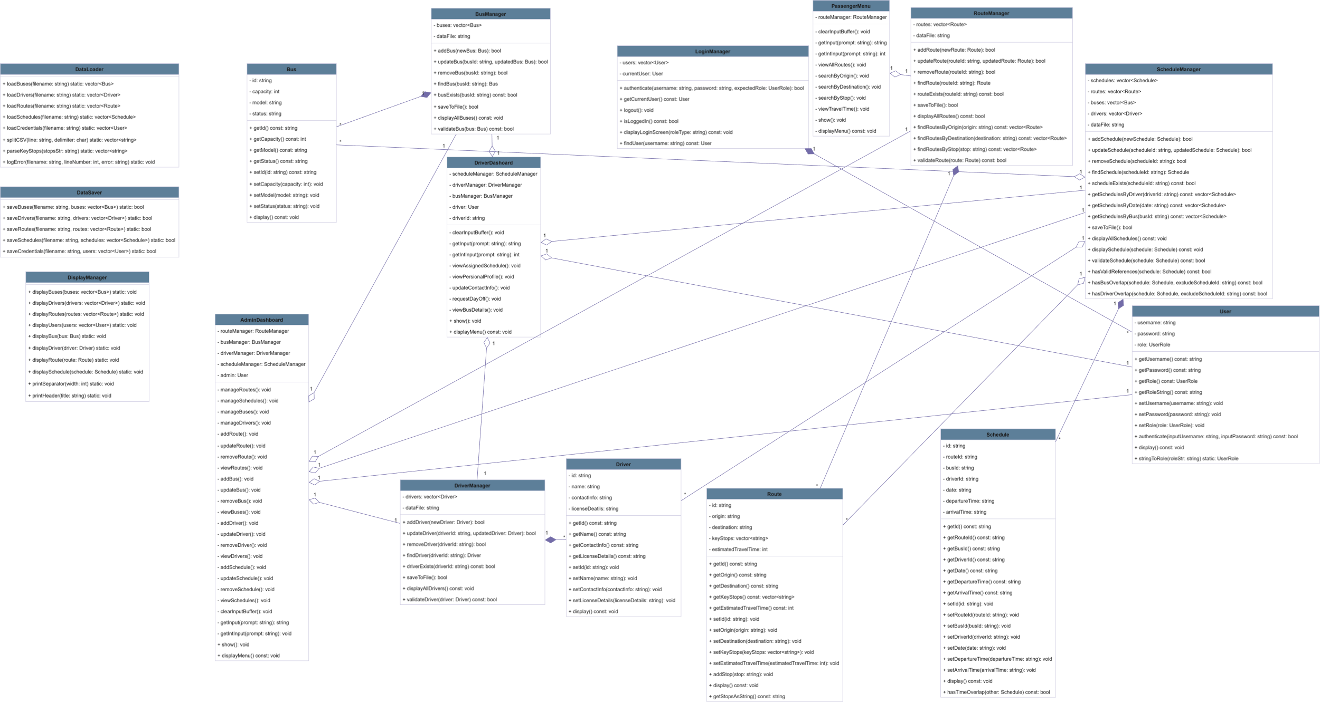
Figure 1 Class Diagram

Object Diagram
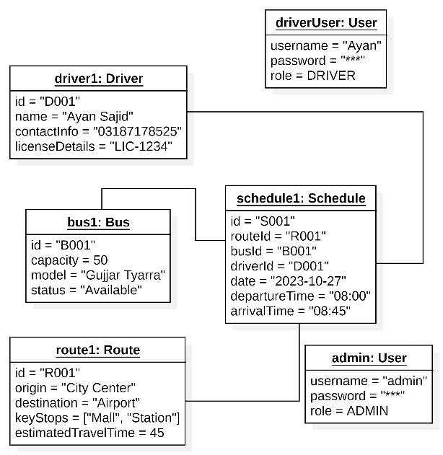
Figure 2 Object Diagram

Use Case Diagram
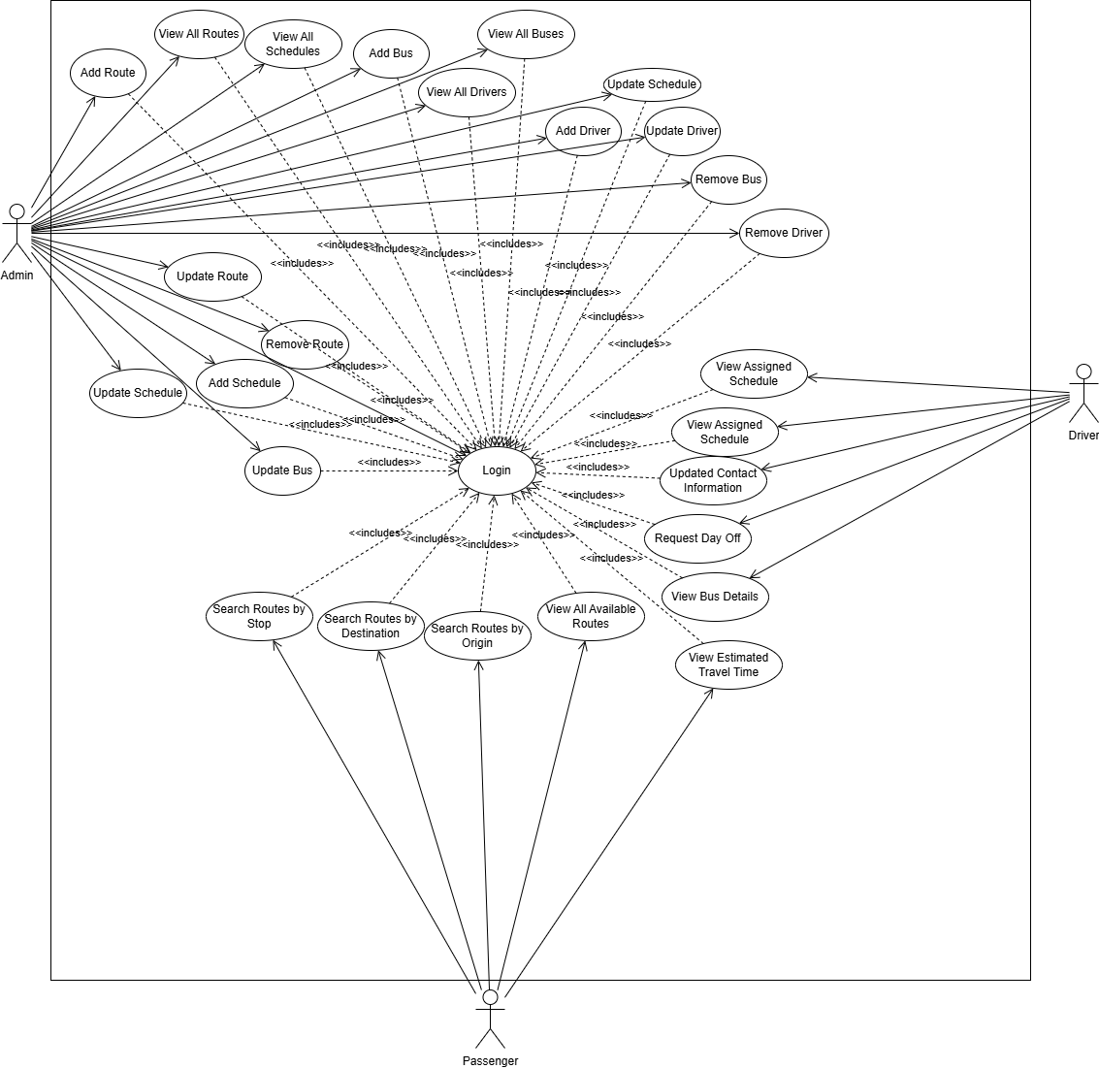
Figure 3 Use Case Diagram

Package Diagram
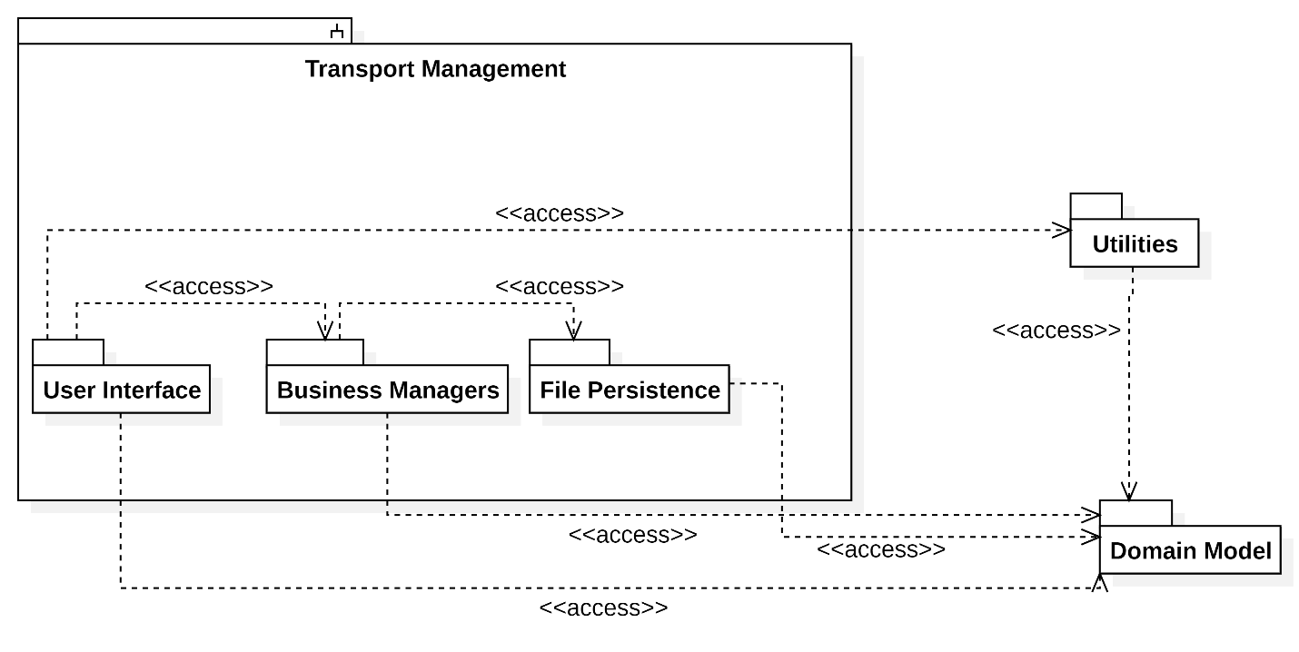
Figure 4 Package Diagram

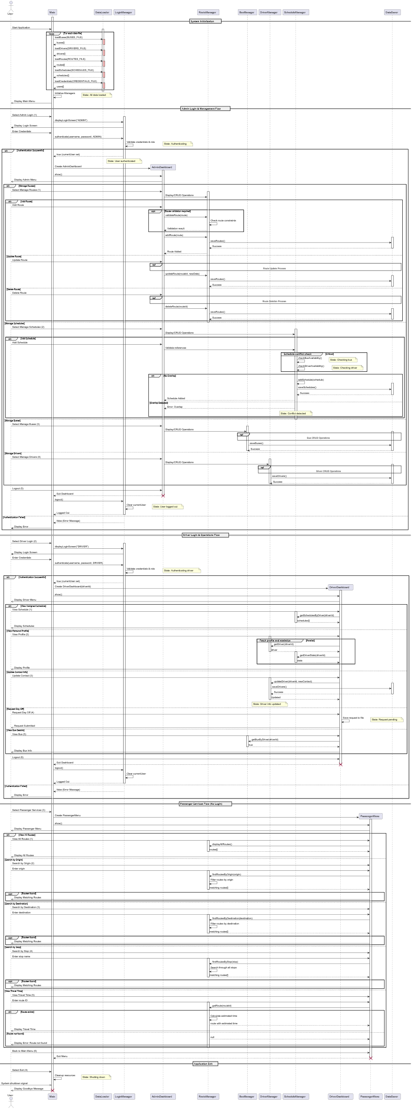
Sequence Diagram
Figure 5 Sequence Diagram

Collaboration Diagram
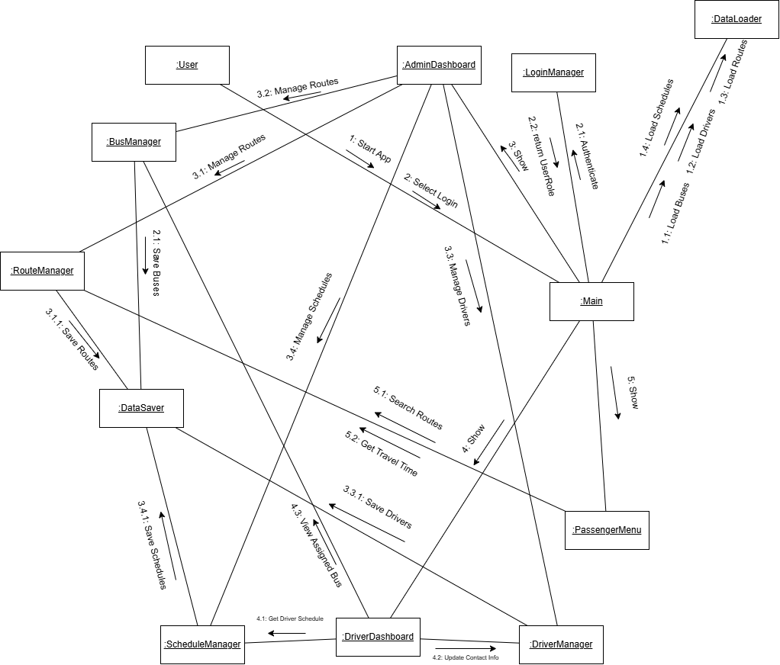
Figure 6 Collaboration Diagram

Deployment Diagram
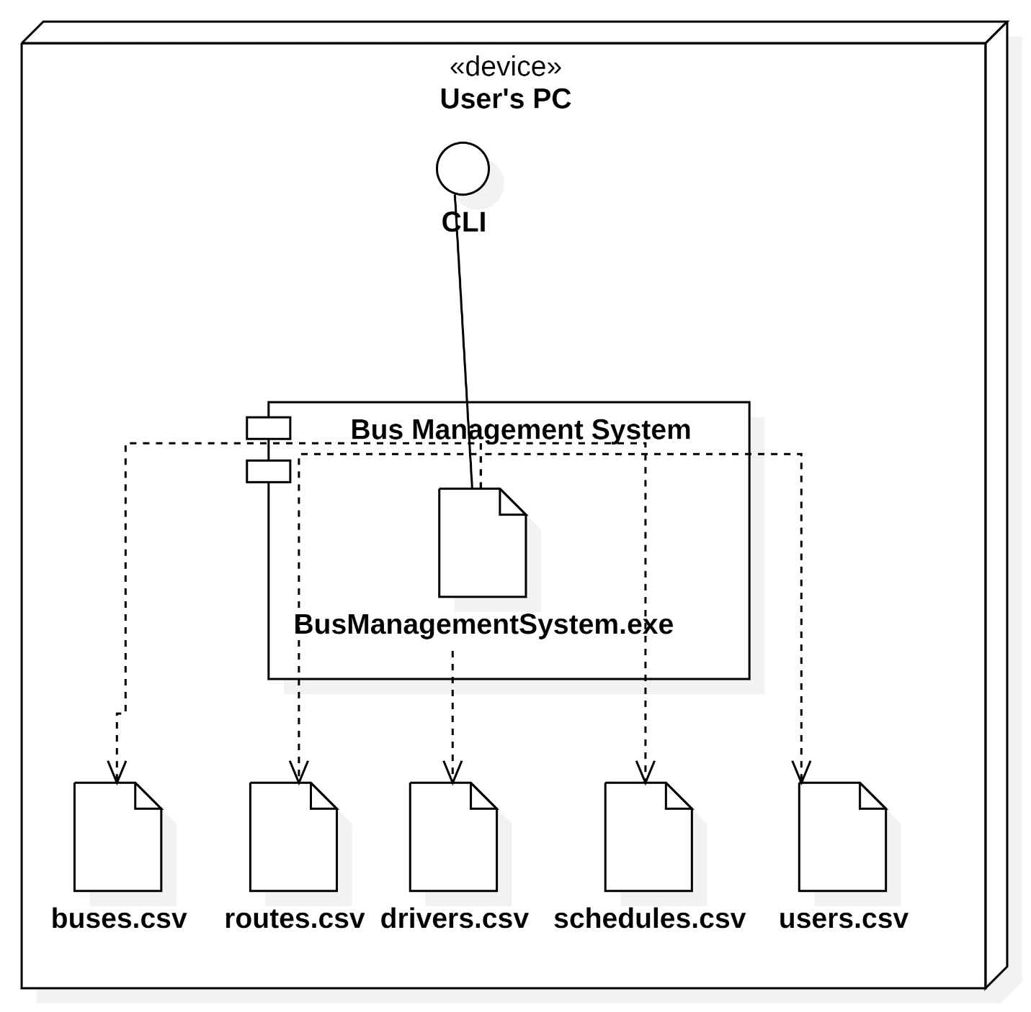
Figure 7 Deployment Diagram

Component Diagram
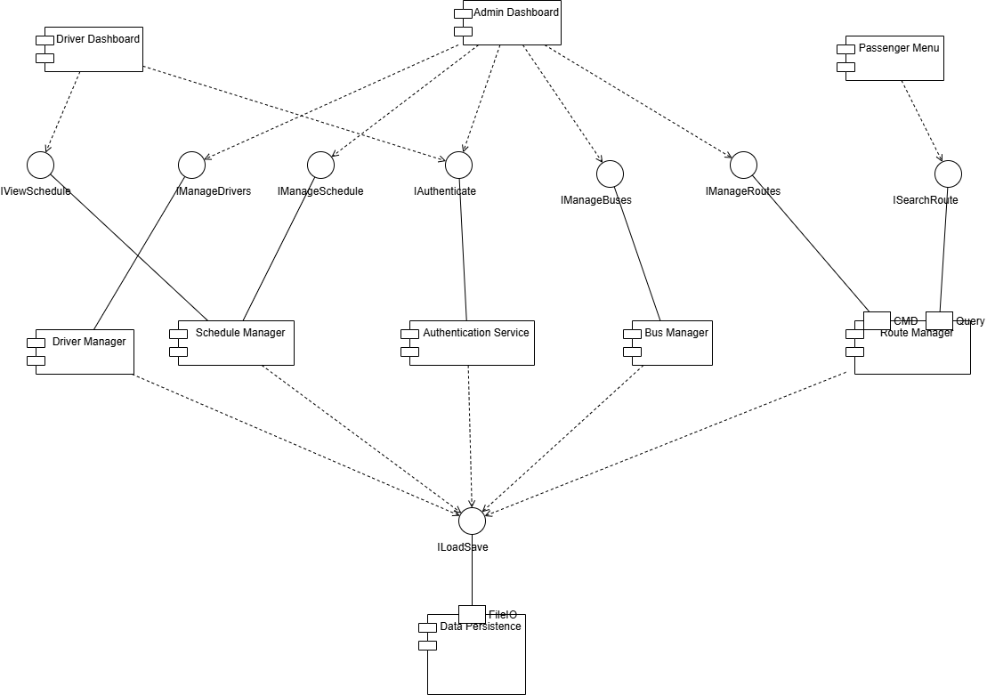
Figure 8 Component Diagram

Activity Diagram

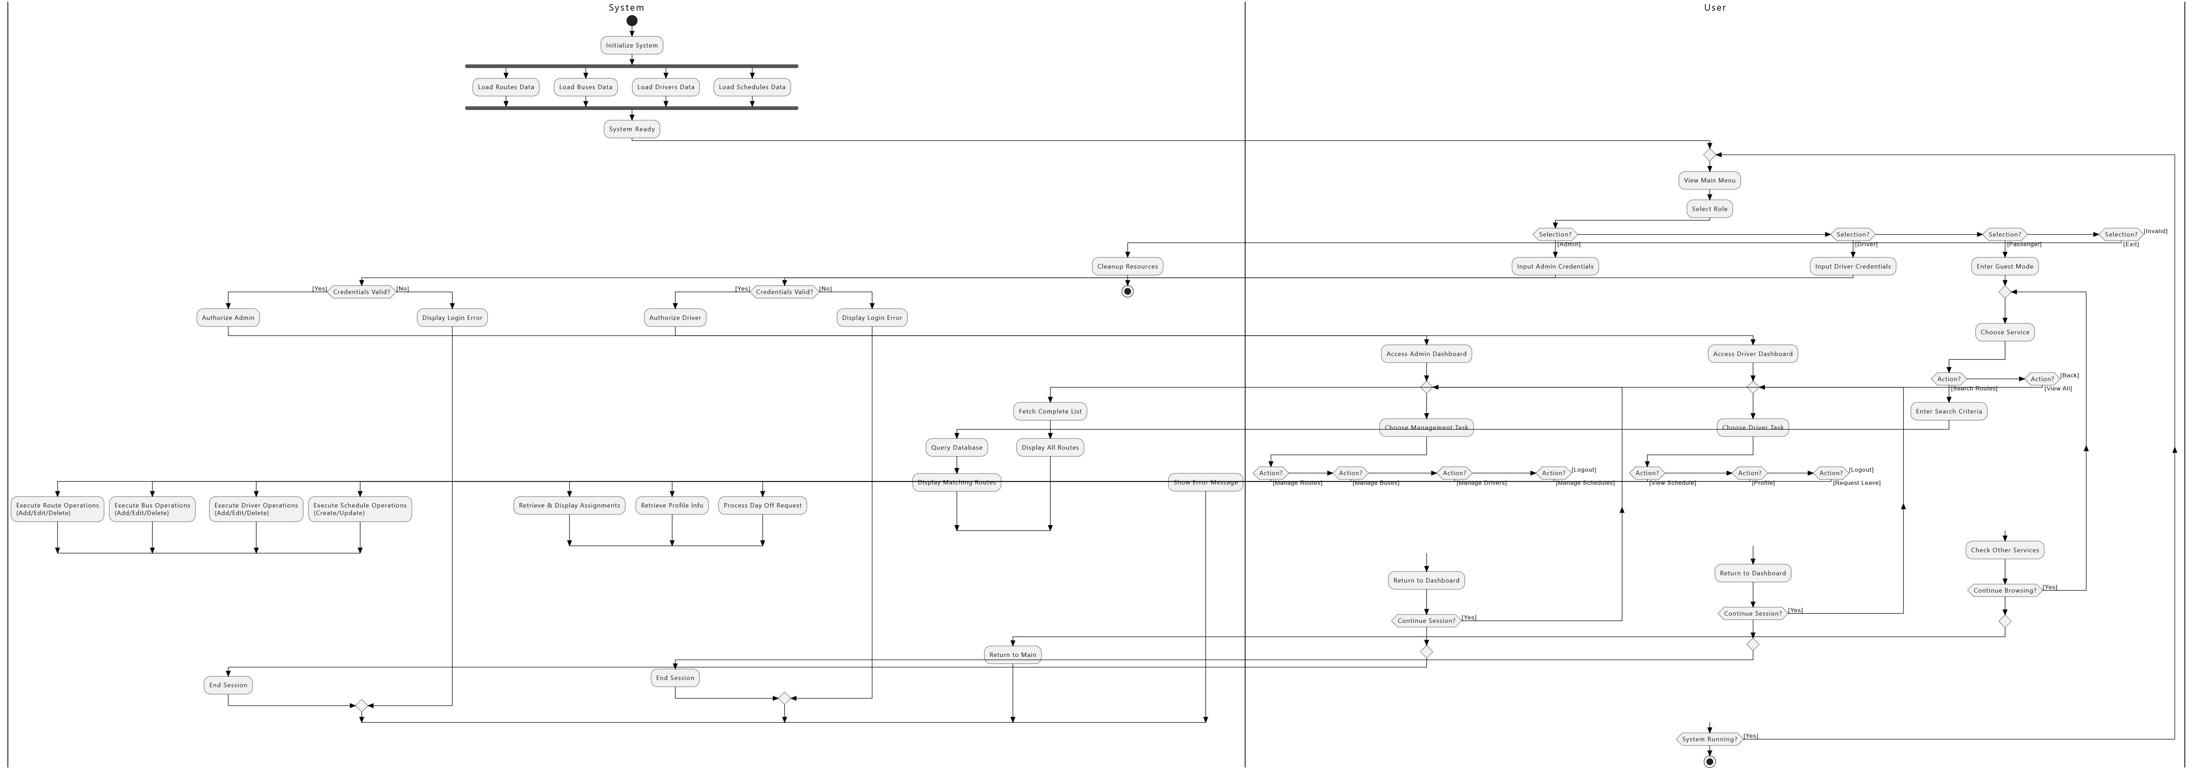
Figure 9 Activity Diagram

State Chart Diagram

Figure 10 Statechart Diagram

